
Federal election scorecard: Housing and homelessness in Melbourne’s west
This survey has been developed by the Western Homelessness Network, which is a Network of the 25 Specialist Homelessness Services, assisting those people who are in need of a home and/or are experiencing family violence in Melbourne’s west.
This survey has been circulated to all Federal election candidates in Melbourne’s west. Responses will be collated into a housing policy scorecard, the extent of each Federal election candidate’s commitment to ending the housing crisis and published prior to the Federal election.
______________________________________________

Safe and affordable homes for all
Having a stable and affordable home is the foundation for good health and mental health, stability, capacity to live a meaningful life and to participate fully in society. It is not acceptable, in a country as wealthy as Australia, that so many Australians do not have a safe, stable home.

Getting the amount of housing we need for our population is possible. After World War II the Government undertook a huge construction program to ensure that returning soldiers all had a place to live. All that is required is the will of all levels of Government.
[Plan Melbourne estimates that Melbourne needs 2.3 M more houses by 2051. Melton and Wyndham are growing faster than any other area of Melbourne but our housing supply is insufficient to house our population. Insufficient housing supply leads to an increase in the cost of housing. This impact is felt particularly strongly in Melbourne’s west: between 53% and 77% of those households who are renting are in rental stress. The housing crisis is impacting those on low incomes the most.]

Public and community housing provides safe and stable homes for those on low incomes. However, there are 13,853 social housing properties in Melbourne’s west and 30,372 households waiting for housing. Many will wait 10 years or more for a home.

- Will you promote the construction of at least 35,000 new public and community homes in Melbourne’s west?
- Do you commit to ensuring that at least 1/4 of all new social homes constructed is public housing so that those people on the lowest incomes will get a home?

Improve the tax system to fund homes for all
Changes to the tax system would free up funds to ensure that every Australian has a home.

House prices in Australia have been rising much faster than incomes for decades. This is fuelled by tax breaks for the wealthy (like negative gearing and capital gains tax exemptions). Federal Governments allocate $1.7B per year to housing and supporting people in need of suitable homes. However, Governments give away $23B a year to capital gains tax, negative gearing and rent assistance.

So, in effect, governments allocate 14 times more money to helping wealthy Australians buy 2, 3, 4, 5 houses than they do to ensuring everyone in Australia has a home to live in. Governments can turn this around to free up funds to ensure every Australian has a home.
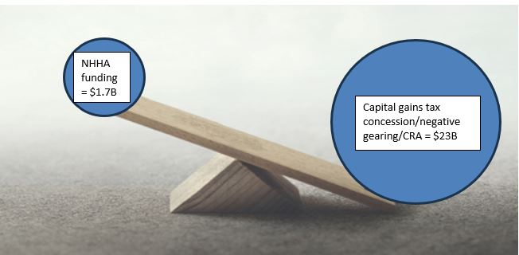

Funding for housing = $1.7B
- Will you prioritise funds to give everyone who needs one, a home to live in, over giving concessions to the wealthy to enable them to buy multiple homes?

Everyone should be able to live securely in a suitable home
We all want everyone in Australia to be able to live securely in a suitable home.

Ensuring everyone has a home is achievable, however lack of Government focus on housing over many decades means that individuals and families can wait years for affordable, safe housing.

The choices our governments make play a powerful role in determining whether people have homes to live in – from the level of income support provided and the amount of social housing built, to the way they run and fund our mental health and family violence systems.
When people have access to safe and affordable housing, decent incomes and support through crisis, homelessness will be rare, and where it does occur, brief and quickly resolved, freeing people up to focus on care their families, work and make connections in their community.

To achieve this, we need all levels of government to prioritise a national strategy with the goal of ensuring safe, decent and affordable homes for all.
The development of a National Housing and Homelessness Plan will hold all levels of Government to account to policy that ensures that safe, stable housing is seen as core social infrastructure, like schools, hospitals and roads.
The Plan must include clear targets and incorporate action on all areas that lead to people being left in need of a home. Ideally the Plan will be enshrined in legislation, so that all future Governments stay true to the Plan.

- Do you commit to developing a National Housing and Homelessness Plan, enshrined in legislation, that addresses all the levers to end Australia’s housing crisis?
Clean, safe and lockable temporary homes
Great innovation in fast, affordable and sustainable housing construction is underway. In Melbourne’s west we have a great deal of vacant land that is available for temporary housing and we have providers, such as Victoria University, with an expertise in building demountable homes at low cost.

It will take time for Governments to construct the housing that we need. In the meantime, we need to look for affordable and creative solutions to create short to medium term housing.

[Individuals and families can wait years for affordable housing. While they wait, they sleep on the streets, in cars, on friends’ couches, in garages, in unsafe and exploitative situations. Homelessness services have some funds to purchase short term stays in hotels and motels. See our Report, the Crisis in Crisis, (Crisis in Crisis: The Appalling State of Emergency Accommodation in Melbourne's north and west (nwhn.net.au)) about how inappropriate and unsafe these options are.]

We asked people in need of a home what safe and appropriate temporary accommodation would be like and they said “their own lockable space that is safe and clean”.

- Do you commit to working with the homelessness sector to develop innovative options for short to medium term accommodation – such as tiny homes and demountables with linked support to help people find long term housing?

Public housing is managed by Government. Community Housing is managed by not for profit agencies. Together they are referred to as social housing.
The Guardian has produced an excellent short explainer video about negative gearing, capital gains tax exemptions and their impact: How did Australia's housing market get so bad, and is it all negative gearing's fault?

