The Housing Crisis in Melbourne

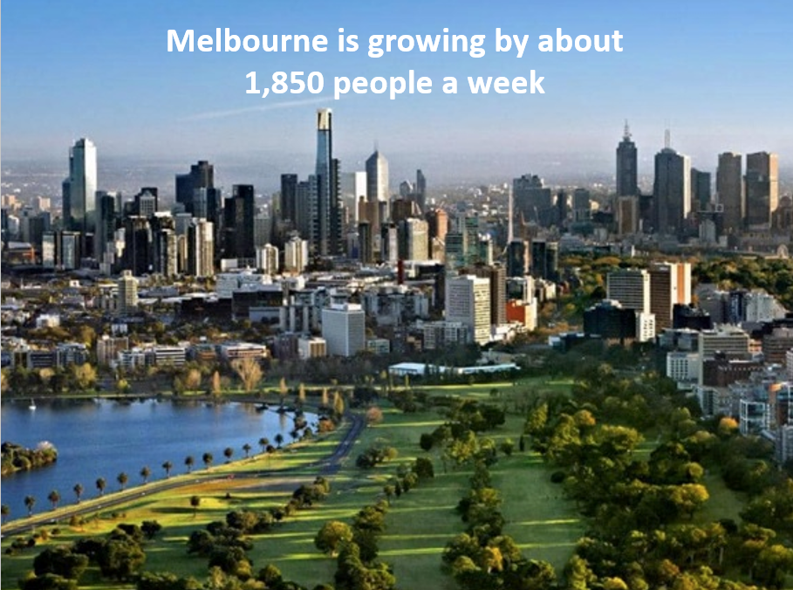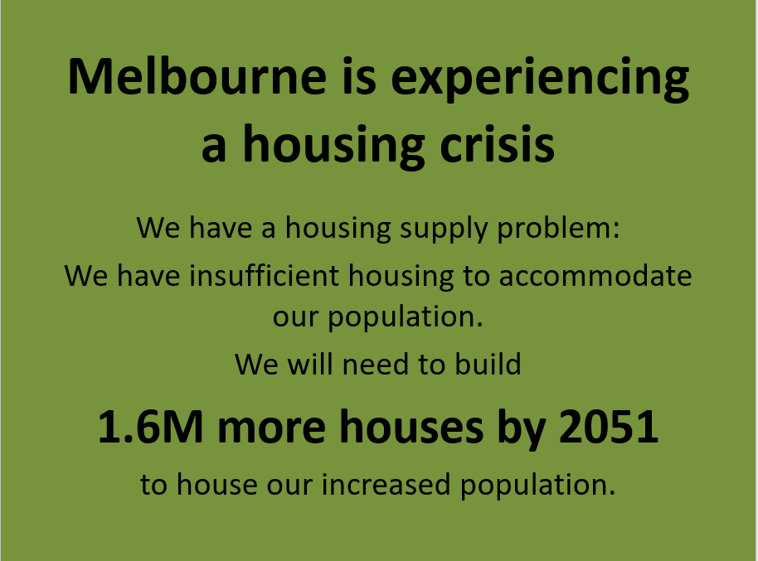

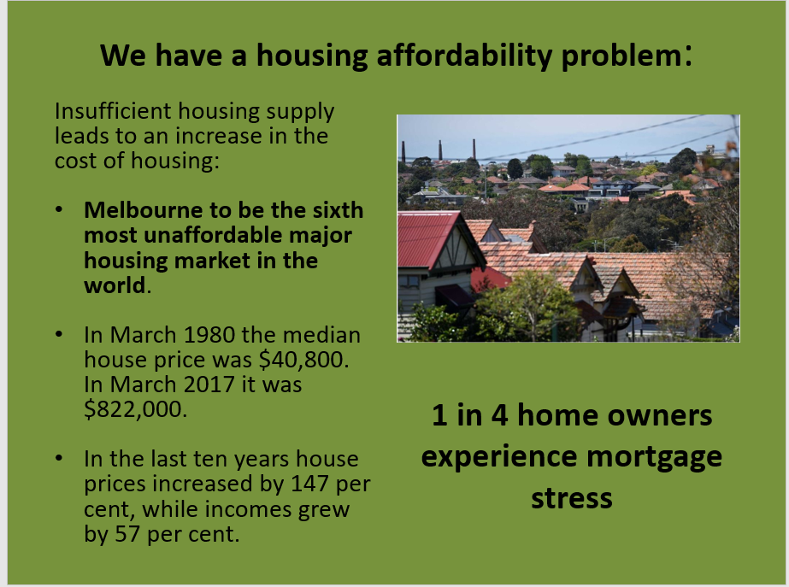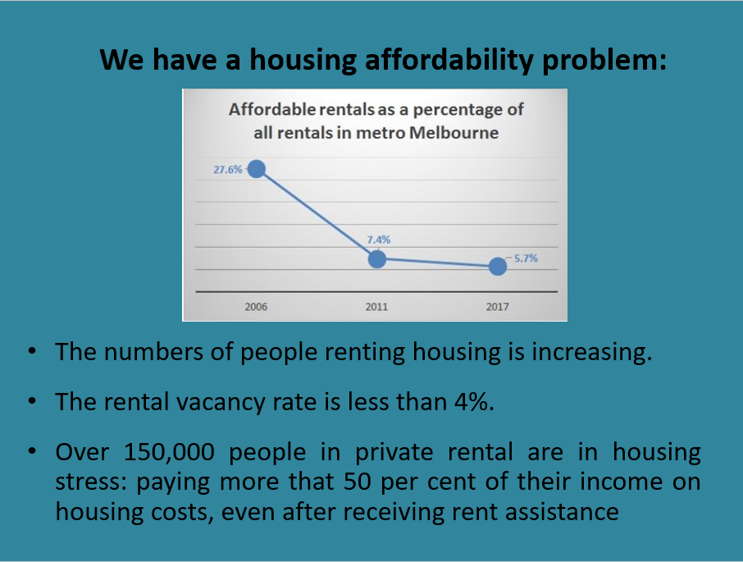

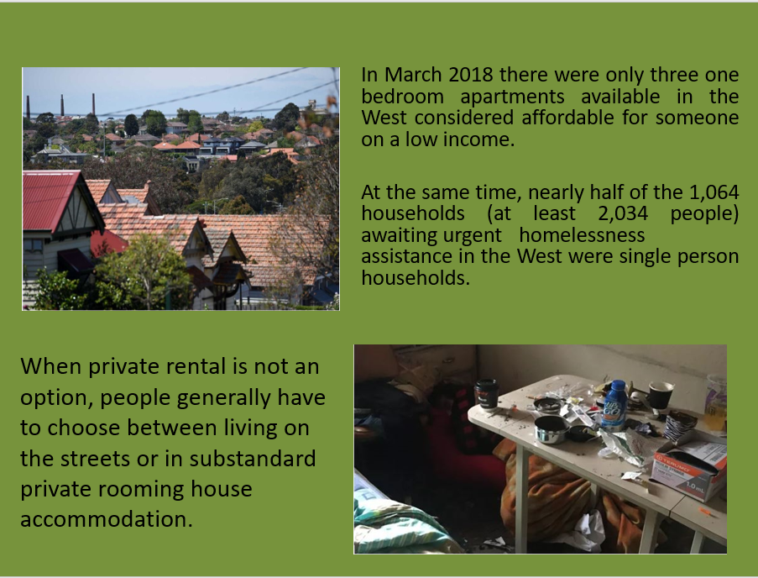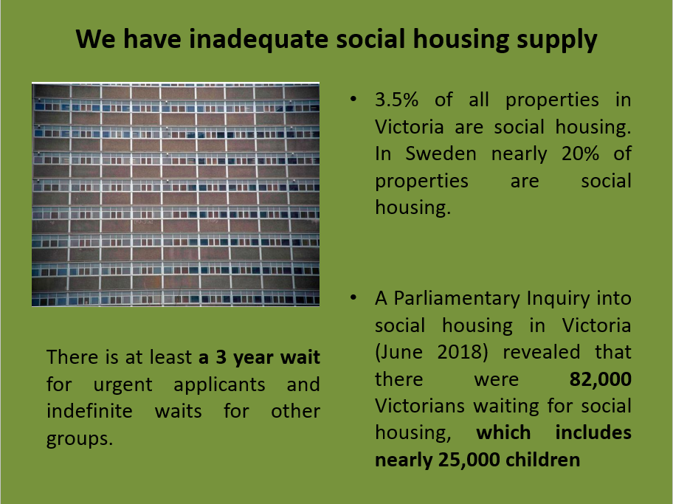

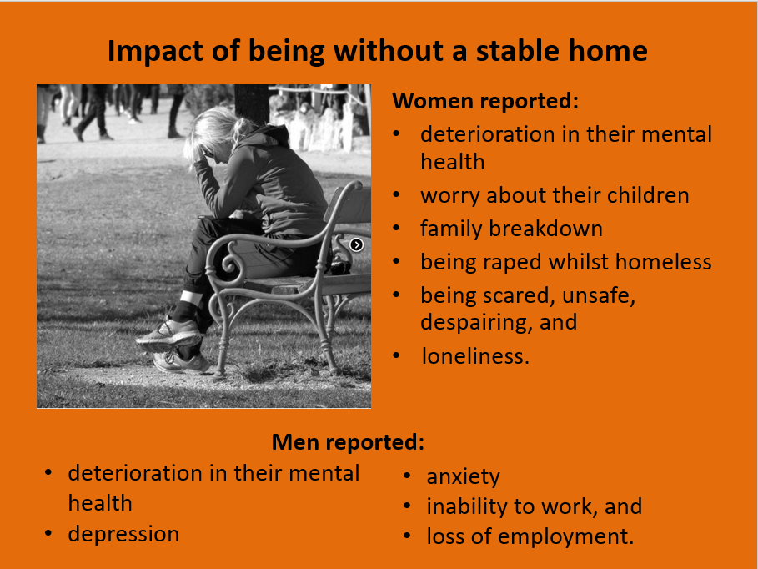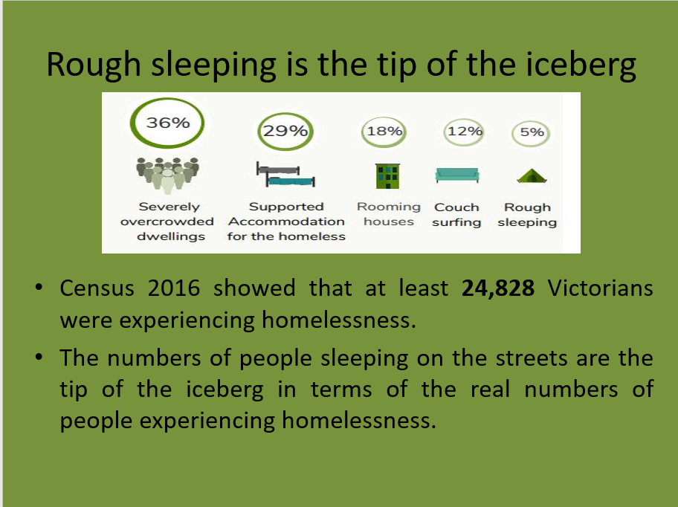

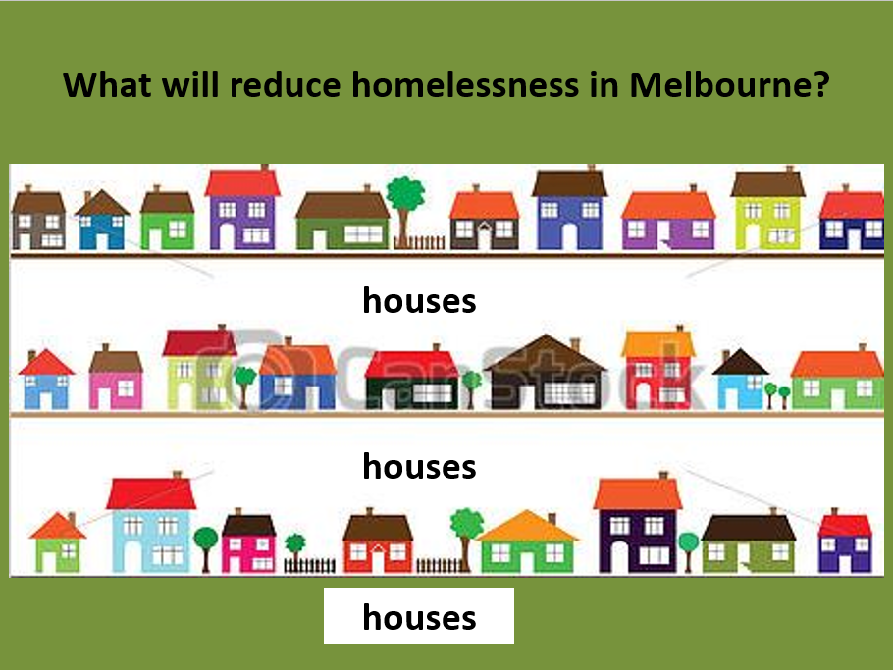

Melbourne is experiencing a housing crisis ……

so more people are becoming homeless

Every Victorian Should Have a Home!

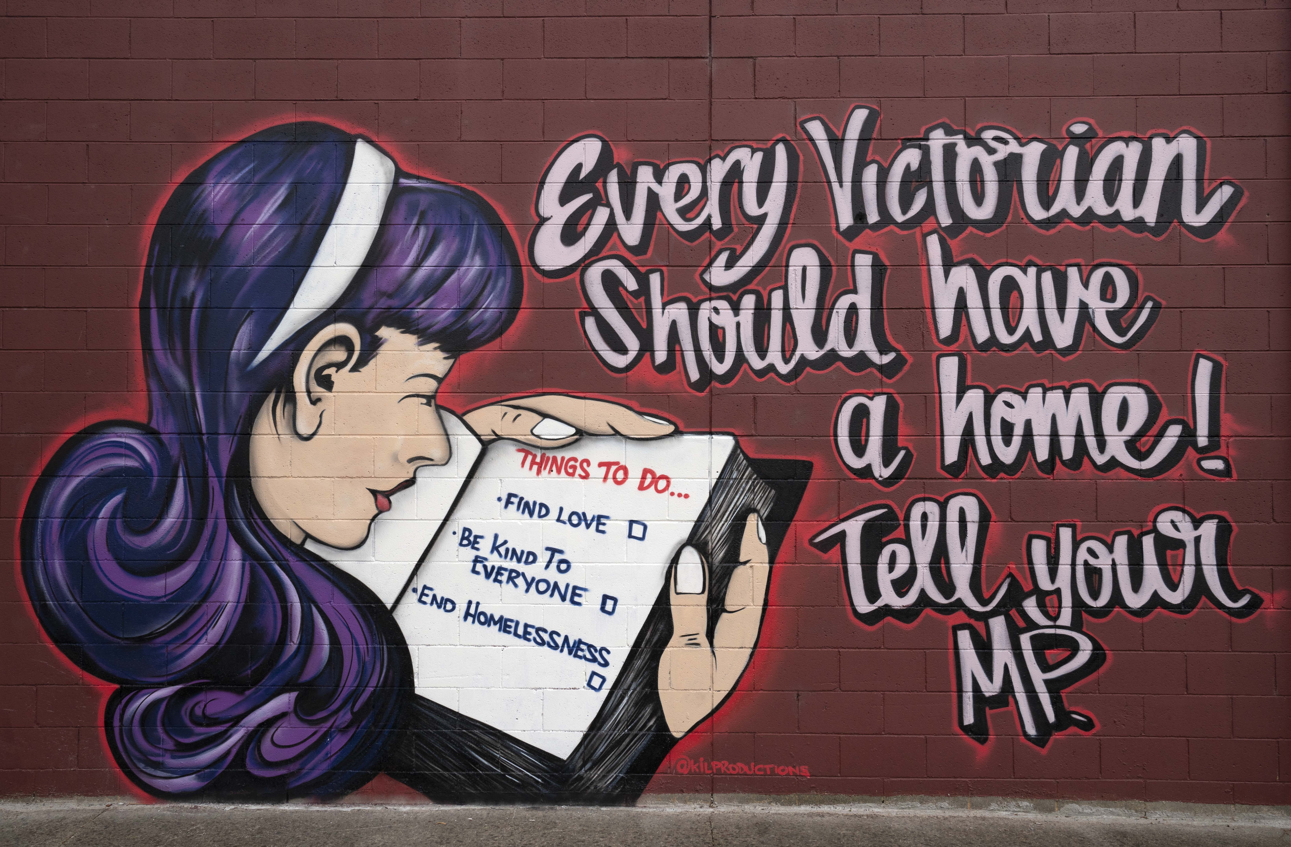

|  |  |
| --- | --- |
| So what do we need?  If we do not address the bigger issues of housing supply and affordability in Melbourne, we will find that more and more people will be forced to sleep in cars and on our streets.  Already in the last five years there has been an increase of 40% in the numbers of people experiencing homelessness in Melbourne’s West and an increase of 74% in people who are visibly homeless in the CBD. | What can I/you do?   * Ring, email or write to your local member of parliament to tell them that every Victorian should have a home * Talk to your friends, family and colleagues about the housing crisis in Victoria * Sign the Everybody’s Home online petition: everybodyshome.com.au/petition |
| **We need:**   * **A monumental boost to social and public housing** * **Legislation that requires a portion of any new housing development to be allocated to those awaiting this housing** * **Construction of innovative temporary accommodation that is safe and self contained.** | The Northern and Western Homelessness Networks are networks of 50 community service organisations managing 180 homelessness programs in Melbourne’s north and west.  For more information contact Meredith Gorman ([Meredith.gorman@launchhousing.org.au](mailto:Meredith.gorman@launchhousing.org.au)) or Sarah Langmore ([sarah@wombat.org.au](mailto:sarah@wombat.org.au)) |