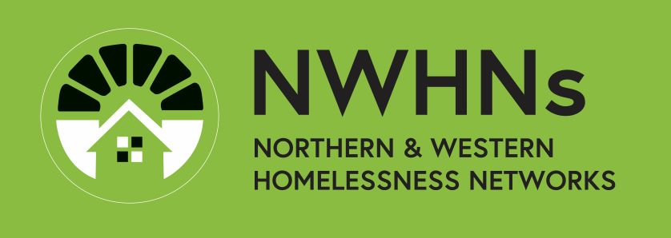

Northern and Western Homelessness Networks’
Annual Consumer System Survey

Participant consent and information form

Background information
This information sheet explains the Consumer Survey and how we would use your responses.

What are we doing and why?
All the homelessness services in Melbourne’s north and west want to improve the way we work with people experiencing homelessness. People with a lived, or living, experience of homelessness are best placed to give us this information and we really value your expertise. Are we meeting your needs? What can we do better? What do you think about what we do?

To do this, every homelessness agency in Melbourne’s north and west is asking people who they are currently assisting if they would like take part in this survey. This is the 12th time we have done this and about 1,500 people have responded so far.

Do I have to take part?
No. It’s up to you and taking part, or not taking part, will have no effect on what happens with your service today, tomorrow or into the future.

How long will it take?
The survey could take 5 minutes, but if you need an interpreter, maybe a little longer.

Will I be paid?
No, sadly we don’t have any funding for surveys. Your participation will help us improve the homelessness system, which will help other people who are experiencing homelessness.

Confidentiality
Your survey is anonymous - we don’t ask for your name.

Your privacy is of high importance to us, and we will do everything possible to stop anyone knowing who you are from the survey you complete.

If you do a paper survey it won’t be kept. We’ll destroy it after we’ve put your answers into the computer.

Your information will be de-identified.

If you do the survey online, information you write in the text boxes will be stored on servers that are located overseas. They won’t have your name, but they will have any other words you’ve written.

Quotes
We would like to be able to quote some responses in the survey, because they are so powerful. We will use these quotes to help us advocate for more housing and homelessness services. We will make sure that no-one will recognise the people whose words we quote

You do not have to answer all the survey questions
This is a survey about your experiences of the homelessness service system.

You may find it hard to talk about things that have happened. If you do decide to take part, you may choose not to answer some questions; that’s okay.

Who developed the survey?
The survey, which takes about 5 minutes to complete, was created by the Northern and Western Homelessness Networks’ Consumer Participation Working Group.

The Consumer Participation Working Group is made up of workers from homelessness agencies and people with lived experience of homelessness. The aim of the Working Group is to develop better ways to include people with a lived or living experience of homelessness in the running of the homelessness service system and to help improve the homelessness system in response to consumer feedback.

What will we do with the information?
We will report our findings back to the Homelessness Networks and they will use it in their planning. We will also use the information to advocate for more housing and homelessness services.

Your worker will be able to provide you with a report of the survey findings. A summary of the survey results will be printed on posters and put up in all the services’ waiting rooms. The final report will also be posted on a special web-page where you can see more details (Consumer survey results (nwhn.net.au)).

You can also call Sarah Langmore on 0407 832 159 (networker@wombat.org.au) to arrange for a copy of the final report to be posted to you. The results will also be shared with other services to help them find out what the people using our services want and how we found that out.

How do you complete the survey?
You (or someone you trust to help you) will need to type your answers into a phone or computer or, if you don’t have either, to answer them on a paper form of the survey.
Your worker will provide you with information about how to complete the survey and then leave you alone to do it in private.

If you have been given a paper survey, the Consumer Participation Working Group will enter the survey into the computer version and destroy the paper copy afterwards. You can also return it to the agency and ask to enter it into the computer yourself, if you want.

Informed Consent
There will be 3 questions at the start of the survey asking if you have understood this consent form, if you have had the chance to ask questions and if they have been answered, and if you are happy to continue with the survey. If you answer ‘yes’ and start the survey, you are giving your informed consent to participate in the project. If you don’t want to go ahead stop the survey.

Emotional Support
Completing a survey such as this may cause distress. Please talk to your worker if this happens to you. They can talk things through with you and help you contact telephone counselling and support services, if you want them.

Complaints and questions
If you have any questions about this research project, feel free to talk to your worker or to contact Sarah Langmore, Western Homelessness Networker, who represents the Consumer Participation Working Group on 0407 832 169 or at: networker@wombat.org.au.

This survey approach has previously been approved by the Anglicare Victoria Research Ethics Committee.

