Outline
Slide | Text
1. Title  1 minute | My name is George Hatvani and I am the Service Development Manager of Launch Housing.  Before I start I would like to acknowledge that we are meeting on the traditional lands of the Wurundjeri people.  I would like to pay my respect to their elders and to any other elders who are present.  I also want to acknowledge that there are other Aboriginal and Torres Strait Islander people who work on these lands and acknowledge their work.  I also want to state the fact that homelessness in this state started with the dispossession of its original people, including the Wurundjeri, and that Aboriginal people continue to be over-represented in the population of people experiencing homelessness at a rate of over five times that of the rest of the population of this state.
2. Introduction  I minute | For the last 8 years I have been working with various members of the North and West local Area service network to increase the participation of people who use specialist homelessness services in these two regions. In particular, Sarah Langmore, Cassandra Bawden, Halime Aldemir, Meredith Gorman, Marcus Findlay, Saranyha Kumar, Lisa Sammut, Vanessa Hille. These and a great many other consumers and employees have been passionately involved in developing ways to hear the voices of the people we work with every year.  The LASN’s themselves have then tried to use that information to improve the experience of people who need to use the coordinated specialist homelessness service system.  I've also spent the last 18 years working in the homelessness sector in Melbourne in specialist homeless outreach to people sleeping rough with complex needs, coordinating teams and managing some of the programs that are part of this integrated and coordinated service system  Here are some key facts presented as numbers…
3. Homelessness is getting worse  30 seconds | Homelessness is getting worse.  When we look at Census data we see a 14% increase in people experiencing homelessness in Victoria since 2011.  Homelessness has increased in parts of Melbourne’s north and west by as much as 86% since 2011 and the numbers of people living in overcrowded dwellings has increased by 91% across Melbourne’s west.  Of the 24,828 people identified as homeless in Victoria on Census night 2016, 41% were in Melbourne’s north and west.
4. We have more of everything  30 seconds | When we look closely at the data prepared by Australia’s Institute of Health and Welfare on people presenting for help at Specialist homelessness services, we can see that Victoria has more of everything.  Victoria’s problem is significantly greater than the rest of the country, and has worsened over the past 12 months
5. Our services are getting overwhelmed  1 minute | While homelessness is not a new phenomenon, the scale certainly is.  Homelessness presentations in Victoria have been increasing every year since the SHS data collection was started by the Australian Institute of Health and Welfare in 2011-12.  Our specialist services are getting overwhelmed  During 17-18, on average, 90 requests for assistance were recorded as unmet each (we know this is a significant undercount as services don’t have the time to record details about people they can’t assist) and every day  It gets worse. This is the reason we have invited you here to today is to tell you about some of the people who we were able to provide a service to.  This is the story of our crisis in crisis accommodation, and what happened when we asked the people we work with what they thought of some of the places we were sending them when they came to us at their most vulnerable.  These are men, women and children, half of them had a disability, and half were already experiencing mental health problems or developed them as a result of the dreadful experience of being homeless, who just couldn’t take it anymore and came to us for help
6. The crisis in crisis #1  Not enough Government Funded Crisis Accommodation Beds  2 minutes | Since 2011, the Consumer Participation Working Group has run an annual consumer system survey across the north and west region. Each year we have asked people who use our services what they think of our system and what needs to change. Since 2011 over 1300 people have taken the time to tell us something of their experience.  Some have been short and to the point, others long and detailed in their pain and anguish. Most have reflected on how much they value the help and the efforts of their workers and the community we represent on their behalf. But, not all of it was positive.  We have learnt a lot, some things we knew, others we suspected, many shocked us.  One thing we knew because our workers kept telling us.  Victoria has only 423 Government funded crisis beds – these are provided by specialist services, they are staffed 24 hours a day, with a range of other services such as nurses, lawyers, AOD and mental health specialists available.  They provide case management and the emotional support and hope needed for people to start the journey out of homelessness or to gain some respite when their experience has just been too overwhelming. However, with targeted stays of around 8 weeks each that works out to around 7 people per each bed per year.  And yet last year we needed to find 9,000 instances of accommodation in addition to those who were able to access these government funded beds.  When 43,000 people present as homeless in 17/18 you can see the problem,  . (NB I think it’s much less)  So where do the rest go?
7. The crisis in crisis #2  Where do the rest go?  2 minutes | They have a choice. They can try to squeeze the last vestiges of good will from their families and friends. They can try their luck with Gumtree and Air BnB, they can go back to their cars and squats or sleeping rough, or they can take a punt on the private short term accommodation providers.  Now, what we are talking about here are the private short term accommodation that people in poverty have always turned to in Victoria, and which the specialist homelessness service system has increasingly relied upon to accommodate people while they wait for long-term, safe affordable housing or a safe and affordable interim solution like transitional housing became available.  It was the existence of this system that in many ways was responsible for hiding the true nature of homelessness in Victoria  These places weren’t great, in fact in 2009 there was a task force established by the Bracks/Brumby Government to try to improve the standards in these places.  While this did lead to many improvements including registration of some rooming houses and a fit and proper test for owners, land value increases led to the loss of many of these and the form itself morphed.  While rooming house operators now need to be registered there are many unregistered operators who exist in the outer and middle suburbs turning poor quality 3 and 4 bedroom houses into appalling mini-rooming houses where 8 – 10 people live. The rent on this accommodation is so high that tenants become trapped there, often without enough money to buy sufficient food.  Our service system tries not to use these unregistered operators, or at least warn people about them when we know about them. And organisations like the Tenants Union, Consumer Affairs Victoria and Local Councils try to expose them as much as they can within their resources.  What the homelessness services system is forced to use however is what is left; the private hotels, motels and caravan parks and these have their own problems
8. The crisis in crisis #3  Loss of the stock that is left  1 minute | On top of the morphing nature of the private short-term accommodation provider marker, the last two decades has seen, mainly through gentrification and the skyrocketing value of Melbourne’s inner and outer city land, the loss of housing of last resort stock.  Since 2013 there has been a loss of over 500 beds (examples below)  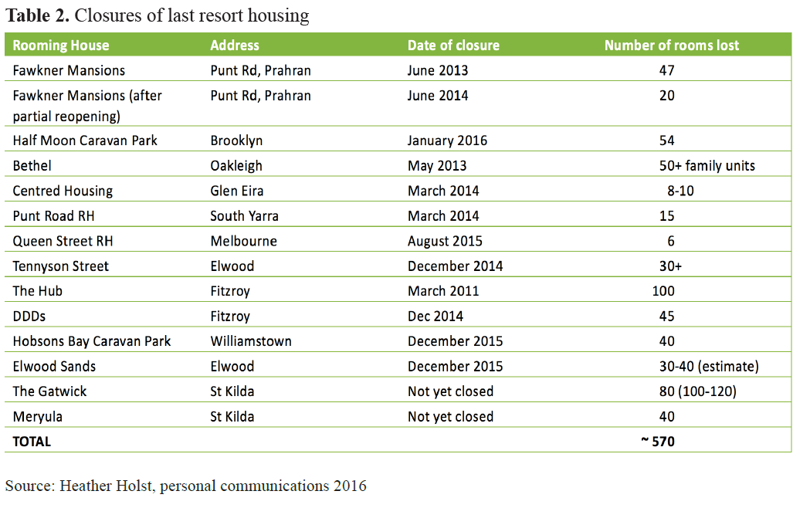  For example, in the past four years, two large hotels that were primarily used for families and single women in crisis have closed - City Gate Apartments and Bethel Hotel. Both these hotels, whilst not ideal, provided a relatively safe option, and importantly, charged weekly rates that were significantly cheaper than nightly rates.  This changing environment resulted in the six homelessness access point services in Melbourne’s north and west, spending $2.5 million of Housing Establishment and other brokerage funds on purchasing emergency accommodation in 2017 alone. This is a 500% increase since 2011  But what were we buying with this money?
9. The crisis in crisis #4  Was having a roof over a person’s head better than nothing?  1 minute | In 2017 the Northern and Western Homelessness Networks conducted their annual Consumer Survey. In response to feedback received from consumers in 2016, the survey focused specifically on people’s experiences of emergency accommodation.  In previous surveys people had given overwhelmingly negative feedback  - They cost too much  - The level of amenity is poor  - They are mostly incredibly unclean, unsanitary places  - Most importantly, they have become places where there is almost no safety  What did people think of the places we were accommodating them? What were their experiences? Was having a roof over a person’s head better than nothing?  The reality of many people’s experience challenges this notion. Consumers reported feeling unsafe, demoralised by the squalor they witnessed, with a growing sense of worthlessness and disconnection from their community. Many reported feeling that the quality of the accommodation was a reflection of the way that their community viewed them.
10. The crisis in crisis #5  In their own words  30 seconds | [Wait for 20 seconds while people read]  Women reported that it was ‘horrible, ‘terrible’, and that they feared violence and rape (one woman actually reported a rape in this form of emergency accommodation).  They said that it was ‘unclean’, ‘not appropriate for children’, that there were ‘no cooking facilities and nowhere to store food’
11. The crisis in crisis #6  In their own words  20 seconds | [Say nothing or 30 seconds while people read
12. The crisis in crisis #7  The risk of harm from homelessness  1 minute | The thing that we know, working in this system every day is what the research tells us and what we see in people who keep coming back to us.  The longer someone is homeless the greater their chances of becoming part of the homeless sub-culture. There is a sense of community here and of solidarity and protection, but it can also lead to exposure to alcohol and other drugs and usually does significant harm to people’s mental health. If there are underlying vulnerabilities these are accentuated.  There is an accumulation of harm to physical and mental health and the impact upon children is heart-breaking.  There is a diminishment of actual realizable opportunities as a person’s world narrows.  Finally, the risk of death for someone experiencing long-term homelessness is between 3 – 8 times that of the general population.
13. The horns or a dilemma  1 minute | For many years now homelessness agencies have felt themselves on the horns of a dilemma  We desperately need more safe, affordable long-term housing, located near employment, transport and schools so that people can get on with their lives and spend as little time as possible in homelessness if it ever comes to that.  On the other hand, the private short-term accommodation market is largely inadequate to meet the basic shelter needs of the people we are seeing and so we desperately need quality safe temporary accommodation to keep people safe until that housing becomes available  The dilemma presented has been that you can have one but not the other, because to build quality crisis accommodation would be at the expense of what could have been long term housing. And so we have strived as hard as we can for the safe affordable long-term housing. But with over 80,000 people on the Vic Public housing wait list and spending far less on social housing than the rest of the country that just does not seem possible at the moment.
14. Conclusion  2 minutes | What I personally, over these last 18 years in the sector, have come to realise is that homelessness is a structural reality of the society we inhabit. It is built in.  This Victorian society, with federal policy settings creating an affordable housing crisis combined with poverty level welfare payments, is built to produce homelessness.  It is not inevitable but under the current policy settings it is inescapable.  Homelessness is not going away and more people are experiencing it for the first time and staying homeless for longer.  If this is the case, if people are going to continue to experience homelessness, probably at ever increasing rates, and without an end in sight for our affordable housing crisis, then we must also have a safe, high quality, affordable temporary accommodation system.  I put it to you that the horns of a dilemma is in fact an illusion, it is a false dichotomy.  Both forms (safe, affordable permanent housing and safe, affordable temporary accommodation) are needed while our society is configured in this way.  And therein lies the dilemma we address today, do we change the systems and society we are part of or do we keep doing it the way we have always done it?  As a sector we have decided: The North and West LASN are no longer prepared to refer people to substandard crisis accommodation, nor are we willing to participate in continuing to harm vulnerable people seeking our assistance.  Thank you

George, could you insert somewhere…
We asked consumers what good crisis accommodation would look like and 85% responded that they would like their own lockable space with facilities (even if it is small) so that they can feel safe, clean and cook for themselves and their children.
What I did not have space for but want to include somewhere…
In addition to these actions and the improvements we are seeking, outlined in the report you now have a copy of (page 4), we will also be establishing an independent, fixed-term Enquiry, to be concluded by end June 2019, to document the evidence to better understand and to identify practical alternatives to the purchase of short-stay private accommodation for people (including families) in crisis experiencing homelessness.

What the LASN is asking for  [Assume this will be covered by later speakers] | [Assume this will be covered by later speakers]  Stage 1 – Immediate (Year 1 and 2)  1. The Victorian Government increases Housing Establishment Fund (HEF) brokerage funding across northern and western Melbourne to enable the purchase of safe and appropriate self-contained emergency accommodation as required;  2. The Networks agree on an approved list of private accommodation providers for a range of cohorts and cease using providers that are considered sub-standard;  3. The Victorian Government funds Crisis Accommodation Outreach Support workers at each homelessness access point in northern and western Melbourne (total of 12 FTE) to provide assistance aimed at rapidly rehousing people placed in emergency accommodation;  4. The Victorian Government sets social housing growth fund targets/KPIs for people experiencing homelessness;  Stage 2 – Intermediate (Commencing immediately, completion within 3- 4 years)  5. The Victorian and Commonwealth Governments, in partnership, construct a variety of secure, self-contained, temporary accommodation options for individuals and families as a safe alternative to existing motels and rooming houses5;  Stage 3 – Long Term (Commencing immediately, completion within 5 years)  6. In line with the Everybody’s Home campaign6, the Victorian and Commonwealth Governments, in partnership, construct sufficient social housing to enable rapid access to a ‘Housing First’ model of housing and support that eliminates reliance on private motels and rooming houses for emergency accommodation.

37% of that 116,000
Chris Chamberlain’s 2012 research
Cost: if the sector puts someone in there it is too expensive to keep up beyond a few weeks at most Amenity: no cooking facilities meaning people are reliant on take-away food or soup vans; there are no recreation facilities so children are cooped up all day with nothing to do and nowhere to go

